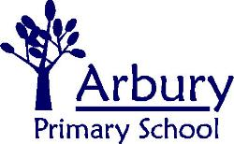
Carlton Way, Cambridge, CB4 2DE

School Telephone: 01223 359568
Email: office@arbury.cambs.sch.uk

Headteacher: Ben Tull

Tuesday 13th October 2020
A Guide to Using eSchools

Dear Parent/Carer,
I am writing to you to give you some guidance on how to access and use our eSchools platform. With the current restrictions and guidelines in place at school it has made contact between teachers and parents less frequent. eSchools is a great way for us to stay in contact via the messaging function and also to communicate home learning tasks to children who are self-isolating.
Teachers check their eSchools messages daily and will reply as soon as they can to any queries you may have or just for a chat with you and your child about things you have been getting up to at home.

How to login to your child’s eSchools account

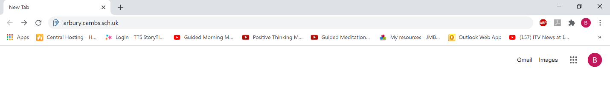
- Open your web browser and go to the school website www.arbury.cambs.sch.uk

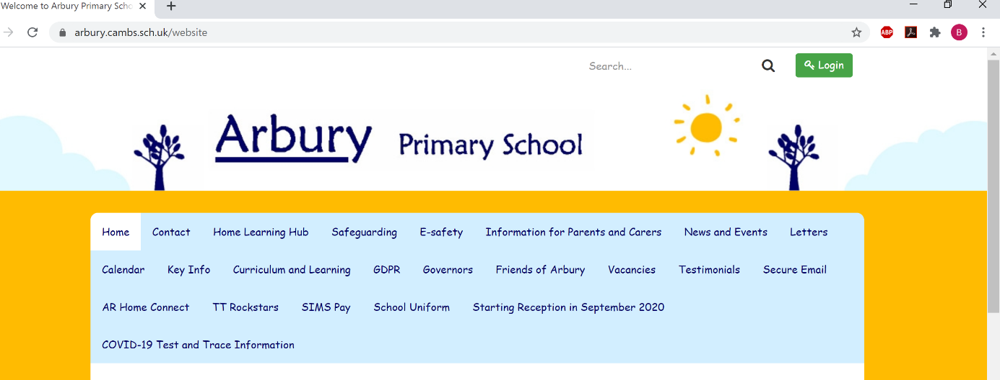
- In the top right hand corner of the school website homepage you will see a green rectangle which says ‘Login’ with a little picture of a key next to it. Click on this button.

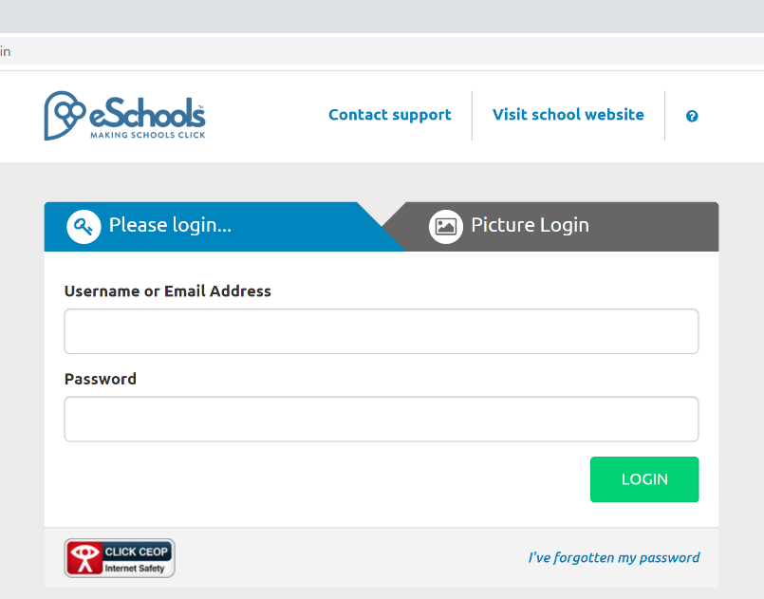
- You will need your child’s username and password for this stage. If you do not have this please contact the school office who will be able to provide you with this.
Type your child’s username in to the username box.
Type their password in to the password box.
Then click Login.

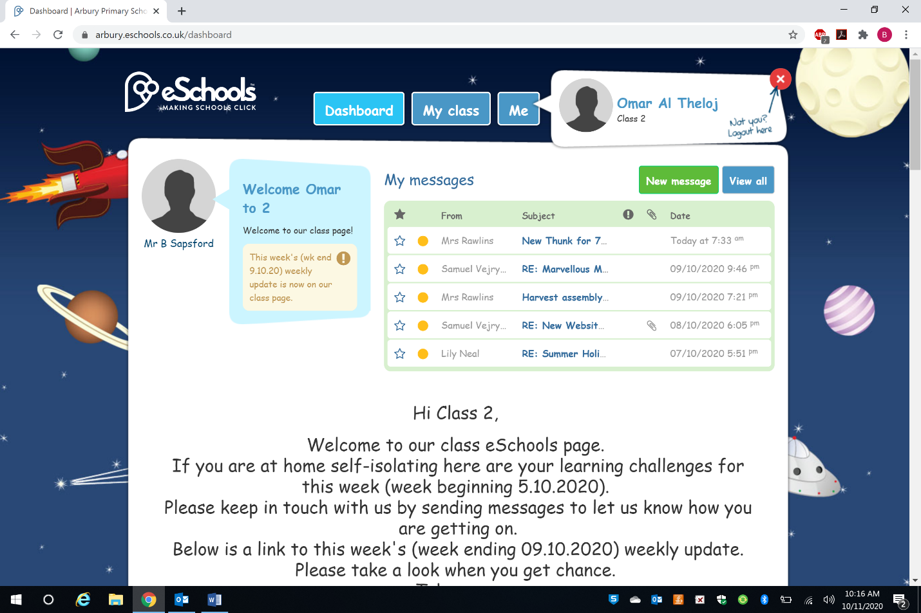
- You will be taken to your child’s class homepage (or ‘Dashboard’ as it’s called on eSchools) which looks like this…
To send us a message click here.
To see all/read your messages click here.
Scroll down to see home learning your child’s class teacher has set for children who are self-isolating as well as other useful links.

How to send your teacher a message

Click ‘New Message’.

- This page will then open up.
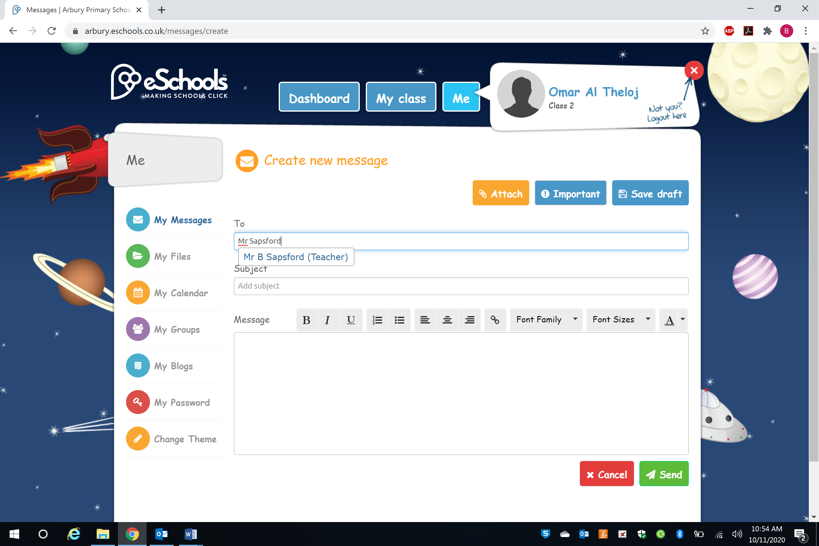
You can attach files, such as pictures or videos, to your message by clicking here.
Type the name of the person who you wish to send a message to here and click their name from the drop down box when it appears.
Type a short sentence explaining what your message is about here.
Type your message here.

Once you have finished writing your message click the green send button here.

I have also put a video showing you how to do all of the above on the school website. You can find it here https://arbury.eschools.co.uk/website/how_to_log_onto_e_schools/514679
Here is a link to the eSchools academy where you can find information and videos on how to use all of the features available on eSchools https://academy.eschools.co.uk/users/students/primary-student/ .
I hope that you have found this information useful. If you have any issues with eSchools please do speak to your class teacher after all of the children have been collected at pick up time and they will be happy to help you.

Best wishes,
Mr Sapsford.

